The Creativity Crisis: It’s Getting Worse

In this very special guest post by Professor KH Kim, we find out the updated facts of what is happening to people’s creativity levels over the past decades, now with updated statistics for 2017. This is a follow-up to what I consider to be one of the most important pieces of creativity research from the past decade.
Glossary:
- A high-stakes test is a test with important consequences for the test taker. Passing has important benefits, such as a high school diploma, a scholarship, or a license to practise a profession. Failing has important disadvantages, such as being forced to take classes until the test can be passed, or difficulty finding employment.
- Filial pietyis a virtue of respect for one's parents, elders, and ancestors.
- Meritocracy - is a political philosophy that holds that certain things, such as economic goods or power, should be vested in individualson the basis of talent, effort, and achievement.

Children are born to be creative, like eagles are born to soar, see the world, and find food, not scratch and fight for scraps in a coop. Instead of competing against each other on memorization tests, when children utilize their creativity to its full potential, creativity can contribute to healthy lives and future careers.

How High-Stakes Testing Has Caused Exam Hell in Asia
High-stakes testing has shaped the main Asian cultural values: 1) filial piety (e.g., to be a good son or daughter by achieving high scores), 2) social conformity (e.g., to think and act like others); and 3) social hierarchy (e.g., to obey the authority). High-stakes testing has made millions of young men focus on preparing for tests, instead of challenging the social hierarchy. It has resulted in exam hell, the excessive rote memorization and private tutoring, starting in early childhood, to achieve high scores among students in Asia. This situation has fostered social conformity and structural inequalities. It has cost Asians their individuality and creativity.

How High-Stakes Testing Has Caused The Creativity Crisis in the U.S.
During the 1990s, American politicians, fearing the educational and economic success of Asia, began to focus on test-taking skills to emulate Asian success. Today, high-stakes testing costs American taxpayers tens of billions of dollars each year, but the real cost is much higher.
Highly-selective university and graduate school admission procedures rely on high-stakes tests such as the ACT and the SAT. Testing companies and test-preparation companies have reaped enormous financial benefits and lobby Congress heavily for more testing. However, since students’ scores are highly correlated with both students’ family income and spending on test preparations, high-stakes testing has solidified structural inequalities and socioeconomic barriers for low-income families.

American Education Before and After the 1990s
Creativity is making something unique and useful and often produces innovation. Prior to the 1990s, American education cultivated, inspired, and encouraged. However, since the 1990s:
1) Losing curiosities and passions. Due to the incentives or sanctions on schools and teachers based on students’ test scores, schools have turned to rote lecturing to teach all tested material and spent time teaching specific test-taking skills. Students memorize information without opportunities for application. This approach stifles natural curiosities, the joy of learning, and exploring topics that might lead to their passions.
2) Narrowing visions. Making test scores as the measure of success fosters students’ competition and narrows their goals, such as getting rich, while decreasing their empathy and compassion for those in need. However, the greatest innovators in history were inspired by big visions such as changing the world. Their big visions helped their minds transcend the concrete constraints or limitations and recognize patterns or relationships among the unrelated.
Prior to the 1990s, many schools had high expectations and offered many challenges. However, since the 1990s:
3) Lowering expectations. Schools focus on students whose scores are just below passing score and ignore high-achieving students.
4) Avoiding risk-taking. High-stakes testing teaches students to bypass challenges for fear of being wrong. The willingness to accept failure is essential for creativity.
Prior to the 1990s, educators sought to provide students with diverse experiences and views. However, since the 1990s:
5) Avoiding collaboration. Since teachers have been compelled to depend on rote lecturing, students have few opportunities for group work or discussions to learn and interact with others.
6) Narrowing minds. Schools have decreased or eliminated instruction time on non-tested subjects such as social studies, science, physical education, arts, and foreign languages. This contraction not only narrows students’ mindsbut gives them few opportunities for finding or expressing their individuality and cross-pollination across different subjects or fields. Low-income area schools, especially, have decreased time on non-tested subjects to spend more time on test preparations.
Prior to the 1990s, schools provided children with the freedom to think alone and differently. However, since the 1990s:
7) Losing imagination and deep thought. Test-centric education has reduced children’s playtime, which stifles imagination. With pressure to cover large amounts of tested material, teachers overfeed students with information, leaving students little time to think or explore concepts in depth.
8) Fostering conformity. American education has increasingly stimulatedconformity, clipping eagles’ wings of individuality: all schools preparing students for the same tests and all students taking the same tests. It has stifled uniqueness and originality in both educators and students. Wing-clipped eagles cannot do what they were born to do – fly; individuality-clipped children cannot do what they were born to do – fulfill their creative potential.
9) Fostering hierarchy. Students’ low scores are often due to structural inequalities, which start in early childhood (e.g., the number of words exposed to by age 3), affecting their later academic achievement. Yet, high-stakes testing has determined the deservingness and un-deservingness of passers or failers. The claim of “meritocracy” has disguised the structural inequalities by conditioning disadvantaged students to blame themselves for their lack of effort.
Results of The 2017 Creativity Crisis Study
In “The Creativity Crisis” I reported that American creativity declined from the 1990s to 2008. Since 2008, my research reveals that the Creativity Crisis has grown worse. In addition, the results also reveal that the youngest age groups (5 and 6-year-olds) suffered the greatest.
The significant decline in outbox thinking skills(fluid and original thinking) indicates that Americans generate not only fewer ideas or solutions to open-ended questions or challenges, but also fewer unusual or unique ideas than those in preceding decades (Figure 1).
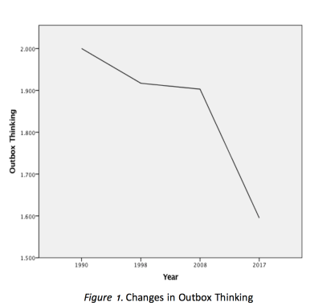
The significant decline in newbox thinking skills (elaboration and simplicity) indicates that Americans think less in depth, with less focus, and they think less critically and in more black-and-white terms than those in preceding decades (Figure 2).
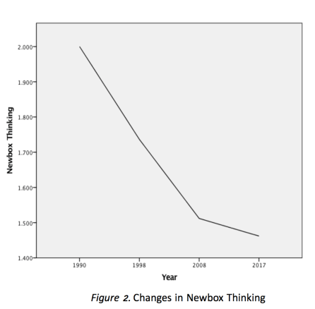
The significant decline in open-mindedness (creative attitude) indicates that Americans are less open to new experiences and different people, ideas, and views than those in preceding decades (Figure 3).
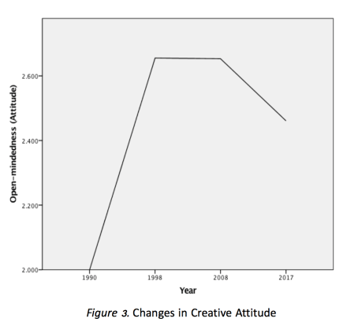
The greatest decline in creativity among the youngest age groups suggests that the younger children are, the more they are harmed by American test-centric education.
Similarities between American high-stakes testing and Asian exam hell have appeared. Increasingly, fewer American innovators will emerge. The longer test-centric education continues, the fewer will remember or know that eagles can fly, and the more we will see creativity and innovation decline. America must not abandon its traditional way of raising eagles. Eagles that soar high will see the whole big world, and children who maximize their potential will become world’s greatest innovators. The world has improved from breakthroughs made by eagles, not by wing-clipped chicks.
Dr. Kim is Professor of Creativity and Innovation at the College of William & Mary (kkim@wm.edu).

